**The correct spellings of Program are Program. Update everywhere. (Programme to Program).**

**Set the default sign out time to Five Minutes.**

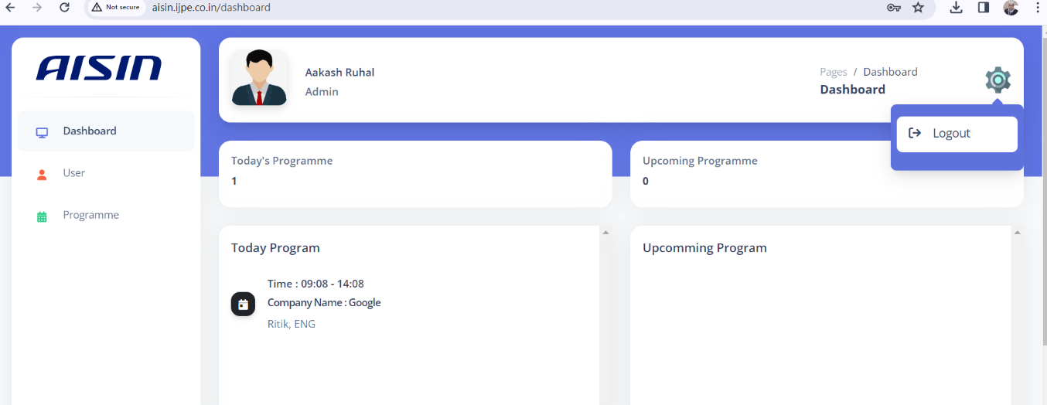

1. Change the sign out icon with attached image (sign out).
2. Add Update Profile in logout section.
3. On Clicking the Update Profile, the login user profile update page opens as per attached screen shot.
4. Mobile No. in user form have increase and decrease button, please remove it.
5. Mobile No. should also have option to country code.
6. Mobile No. validation Message: Mobile No. should be 10 digit numeric only.
7. Add one more label and text box in Create User Form after Mobile No. Location

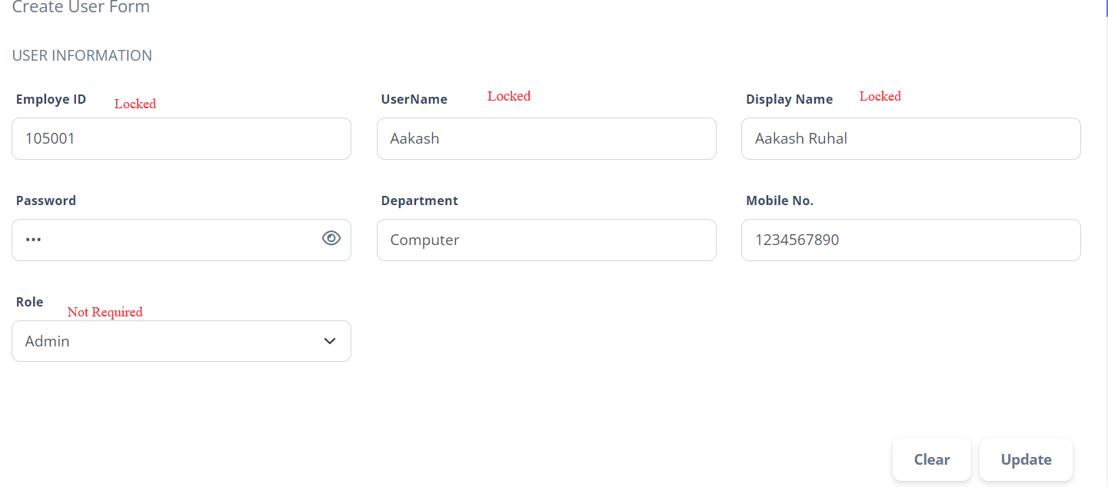

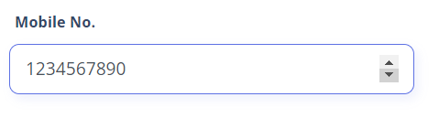

1. Change label text Create Programme Form to Schedule New Program
2. Change label text PROGRAMME INFORMATION to Program Information
3. Change label text Company Name to Visitor Company.
4. Change label text Person Name to Visitor Name.

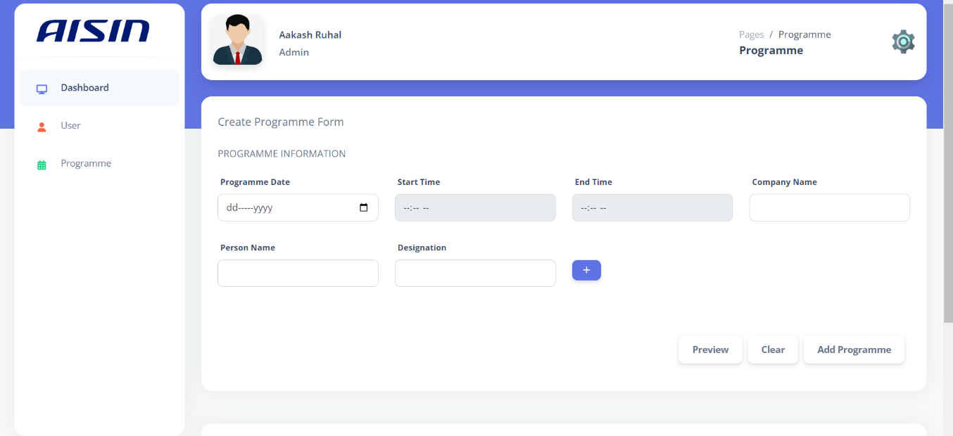

1. Change Message Maximum inputs reached to You can entered maximum five person details.

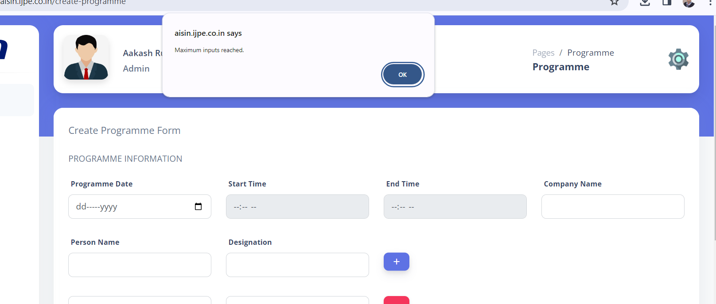

1. In Preview on clicking the AISIN Logo it signs out the user, please remove the action only.
2. In Preview and Today Programme add Label Visitor Company like:

Visitor Company: Maharshi Dayanand University Rohtak

1. In Preview and Today Programme display the designation in a separate column like

|  |  |  |
| --- | --- | --- |
| Time: | Kuldeep | Programmer |

1. In Preview and Today Programme Give the Border to Grid view Like:

|  |  |  |
| --- | --- | --- |
| **Maharshi Dayanand University Rohtak** | | |
| Time: 12:20 - 13:22 | Kuldeep  Rahul | Programmer  Junior Programmer |

1. Preview and Today Programme have different type of date format, Preview Date also have the same Date Format as in Today Programme

